PROJECT TITTLE: Application specific access policies
using Zscaler private access(zpa)

COLLEGE NAME:Nandha Arts And Science College COLLEGE CODE:BRU4J
GROUP CODE:SWTID-2026-9422 CONTACT:SWTID-2026-8693

TEAM DETAILS

Team leader name: DHARANISH S Email:dharan0118@gmail.com
Team Member: DARSHA SABARISH R Email:rdarshasabarish@gmail.com Team Member: GOKULAKANNAN J Email:naveentraveler0@gmail.com Team Member: HARIKRISHNAN M Email:krishnanhari40819@gmail.com Team Member: KAJOTHARA M
Email :maxwellkajo8@gmail.com

INTRODUCTION
Application-Specific Access Policies using Zscaler Private Access (ZPA) is a modern cloud security approach that provides secure access to internal applications without exposing the corporate network to the internet. ZPA is part of the Zero Trust security model, where access is granted only after verifying the identity of the user and device.
Traditional VPN solutions allow users to connect to the entire network once authenticated, which increases security risks. In contrast, ZPA follows a Zero Trust Architecture, where users are given access only to specific applications instead of the full network. This method reduces the chances of unauthorized access and cyber threats.
In ZPA, application-specific access policies are created by administrators to control which users can access particular applications. These policies are defined based on different factors such as user identity, device type, location, and security posture. For example, an employee in the finance department can be given access only to financial applications, while developers may access development tools.
The working process of ZPA involves several components such as the ZPA App Connector, Zscaler Cloud, and ZPA Client Connector. The user sends a request to access an application through the ZPA Client Connector. The request is verified by the Zscaler cloud platform, and if the policy conditions are satisfied, a secure connection is established between the user and the application without exposing the internal network.
The main advantages of using application-specific access policies in ZPA include improved security, reduced attack surface, better user experience, and simplified network management. Since applications are hidden from the public internet, it becomes difficult for attackers to detect or access them.

ABSTRACT
With the increasing use of cloud technologies and remote work environments, organizations require secure and reliable methods to access internal applications. Traditional network security solutions such as Virtual Private Networks (VPNs) often provide broad access to the entire network once a user is authenticated, which can increase security risks. To overcome these challenges, modern security frameworks such as Zero Trust Architecture have been introduced.
This project focuses on Application-Specific Access Policies using Zscaler Private Access (ZPA). ZPA is a cloud-based security solution that enables secure access to internal applications without exposing the corporate network to the public internet. Instead of granting full network access, ZPA allows organizations to define policies that provide users with access only to the specific applications they are authorized to use.
In this system, administrators can create application-specific policies based on user identity, device type, location, and security requirements. When a user attempts to access an application, the request is verified through the Zscaler cloud platform. If the user meets the defined policy conditions, a secure connection is established between the user and the application through the ZPA App Connector.
The implementation of application-specific access policies improves overall network security by reducing the attack surface and preventing unauthorized access to sensitive resources. It also enhances user experience by providing seamless and secure connectivity to applications from any location.
This project demonstrates how Zscaler Private Access can be used to implement Zero Trust principles and provide secure, scalable, and efficient access to enterprise applications.

USE CASE SENARIO:

Secure Remote Employee Access
In this scenario, an employee working from home needs to access internal company applications such as HR systems or internal portals. Using Zscaler Private Access (ZPA), the user connects through the ZPA Client Connector. The system verifies the user identity and device security before granting access. If the access policy conditions are satisfied, the employee is allowed to access only the required application instead of the entire network.

Department-Based Application Access
Organizations often have multiple departments such as Finance, HR, and IT. Each department requires access to specific applications. Using application-specific access policies, administrators can configure rules that allow finance employees to access financial applications while restricting other users. This ensures that sensitive information is protected and only authorized users can access it.

Secure Third-Party Vendor Access
Sometimes external vendors or partners need temporary access to internal applications for maintenance or support purposes.
With ZPA, administrators can create limited access policies that allow vendors to access only specific applications. This prevents vendors from accessing other internal systems and improves overall security.

Location-Based Access Control
In this use case, access to certain applications is restricted based on the user’s location. For example, employees can access sensitive applications only when they are inside the organization’s trusted network or approved locations. If the user attempts

access from an unknown location, the system will deny access according to the policy rules.

Secure Access for Mobile Users
Employees using laptops or mobile devices while traveling may need access to internal applications. ZPA provides secure access through encrypted connections and verifies device security before granting permission. This ensures that only trusted devices and authenticated users can access the applications safely

STAGE 1
TITTLE: Application-specific access policies using Zscaler Private Access (ZPA)

OVERVIEW:
Application-Specific Access Policies using Zscaler Private Access (ZPA) is a cloud-based security solution designed to provide secure access to internal applications without exposing the corporate network to the internet. In modern organizations, employees often work remotely and require access to company applications from different locations and devices. Traditional security methods such as Virtual Private Networks (VPNs) allow users to access the entire network once they are authenticated, which increases the risk of unauthorized access and cyber attacks.
Zscaler Private Access follows the Zero Trust security model, where no user or device is trusted by default. Instead, access is granted only after verifying the identity of the user and ensuring that the device meets the required security standards. With application-specific access policies, users are allowed to access only the particular applications they are authorized to use rather than the full network.
In this system, administrators can define policies based on factors such as user identity, department, device type, and location. When a user attempts to access an application, the request is validated by the Zscaler cloud platform. If the user meets all policy conditions, a secure and encrypted connection is established between the user and the application through the ZPA App Connector.
The main goal of this project is to demonstrate how organizations can implement secure and controlled access to internal applications using Zscaler Private Access. This approach improves network security, reduces the attack surface, and ensures that only authorized users can access sensitive resources within the organization.

LIST OF VULNERABILITY

SNO | Vulnerability name | Cwe/Cve no
1 | Absolute Path Traversal | CWE 36
2 | Sensitive cookie in https session without  secure attribute | CWE 614
3 | Use of unmaintained  third party components | CWE 1104

REPORT:
Vulnerability:Absolute path traversal Cwe/cve no:CWE 36
Owasp category:AOS:2025 BROKEN ACCESS CONTROL

DESCRIPTION:
Absolute Path Traversal is a security vulnerability that allows an attacker to access files and directories that are stored outside the intended application directory. This occurs when a web application does not properly validate or sanitize user input used in file paths. As a result, attackers may manipulate the file path and gain unauthorized access to sensitive system files.
In this vulnerability, an attacker can use special characters such as “../” or absolute file paths to navigate through the server’s file system. By exploiting this weakness, the attacker may read confidential files such as configuration files, system files, or application data that should not be accessible to normal users.
Absolute Path Traversal is categorized under Broken Access Control in the OWASP Top 10 because it allows users to bypass normal security restrictions and access restricted resources. If this vulnerability is not properly addressed, it may lead to serious security risks including data leakage, exposure of sensitive information, and potential system compromise.
To prevent this vulnerability, developers should implement proper input validation, restrict file access to specific directories, and avoid directly using user-supplied input in file path operations. Additionally, security mechanisms such as access control checks and secure coding practices should be applied to protect the application from path traversal attacks.

BUSSINESS IMPACT:
The Absolute Path Traversal vulnerability can have serious impacts on an organization’s security and business operations. If attackers exploit this vulnerability, they may gain unauthorized access to sensitive files stored on the server. These files may include configuration files, system information, user data, or application source code.
Unauthorized access to such critical information can lead to data leakage, which may expose confidential business data and customer information.
This can damage the organization’s reputation and reduce customer trust. In addition, attackers may use the accessed information to perform further attacks on the system.
This vulnerability may also result in financial losses, legal issues, and compliance violations if sensitive data is exposed. For example, organizations that handle customer data must follow security regulations, and a data breach caused by this vulnerability may lead to penalties or legal consequences.
Therefore, it is important for organizations to identify and fix Absolute Path Traversal vulnerabilities by implementing proper input validation, secure file handling, and strong access control mechanisms. Preventing this vulnerability helps protect sensitive data and ensures the overall security of the system.

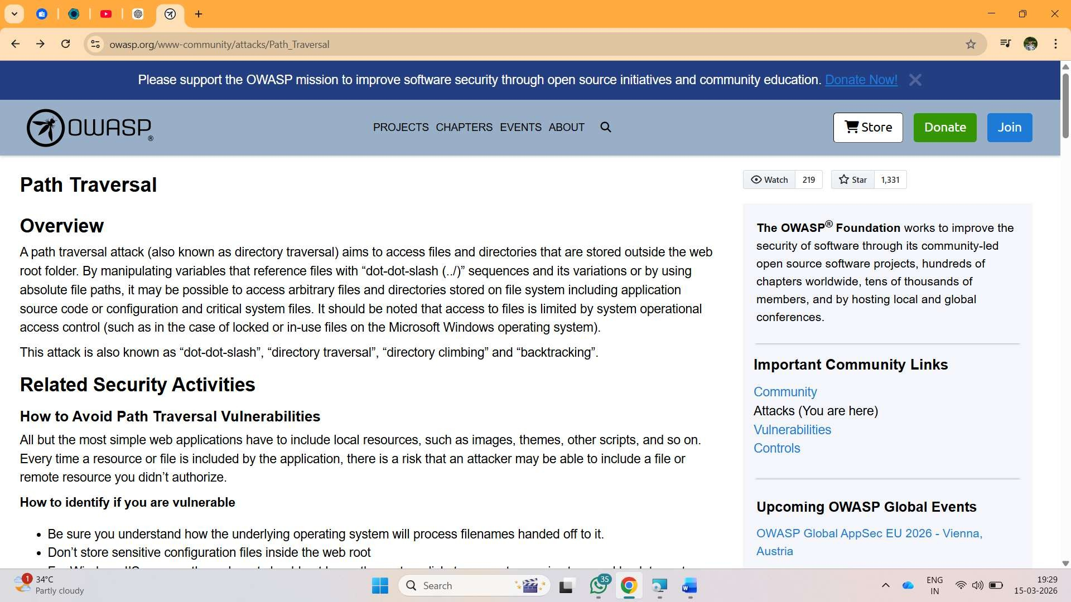

Vulnerability: Sensitive cookie in https session without secure attribute Cwe/cve no:CWE 614

DESCRIPTION:
Sensitive Cookie in HTTPS Session without Secure Attribute is a security vulnerability that occurs when a web application sends cookies over an HTTPS connection but does not set the Secure attribute for those cookies. The Secure attribute ensures that cookies are transmitted only through encrypted HTTPS connections and not through unencrypted HTTP connections.
If the Secure attribute is not enabled, the browser may send the cookie over an insecure HTTP connection if the user accidentally accesses the website using HTTP. This can expose sensitive information such as session IDs, authentication tokens, or user data to attackers.
Attackers can exploit this vulnerability by performing network attacks such as Man-in-the-Middle (MITM) attacks to intercept cookies transmitted over insecure channels. Once the attacker obtains the session cookie, they may be able to hijack the user’s session and gain unauthorized access to the application.
This vulnerability can compromise user accounts, expose sensitive information, and affect the overall security of the application. Therefore, it is important for developers to configure cookies with the Secure attribute so that they are transmitted only through encrypted HTTPS connections.

BUSSINESS IMPACT:
The vulnerability Sensitive Cookie in HTTPS Session without Secure Attribute can create serious security risks for an organization. If cookies that store session information are not protected with the Secure attribute, attackers may intercept these cookies through insecure network connections.
By capturing the session cookie, attackers can perform session hijacking, where they take control of a user’s active session without needing the user’s login credentials. This may allow unauthorized users to access

sensitive data, modify information, or perform actions within the application as a legitimate user.
Such security breaches can lead to data exposure, loss of confidential information, and unauthorized access to user accounts. This may also damage the organization’s reputation and reduce customer trust in the system.
In addition, if user data or sensitive information is compromised, the organization may face financial losses, legal issues, and compliance violations related to data protection regulations. Therefore, it is important to secure session cookies properly to protect both the application and the organization from potential security threats.

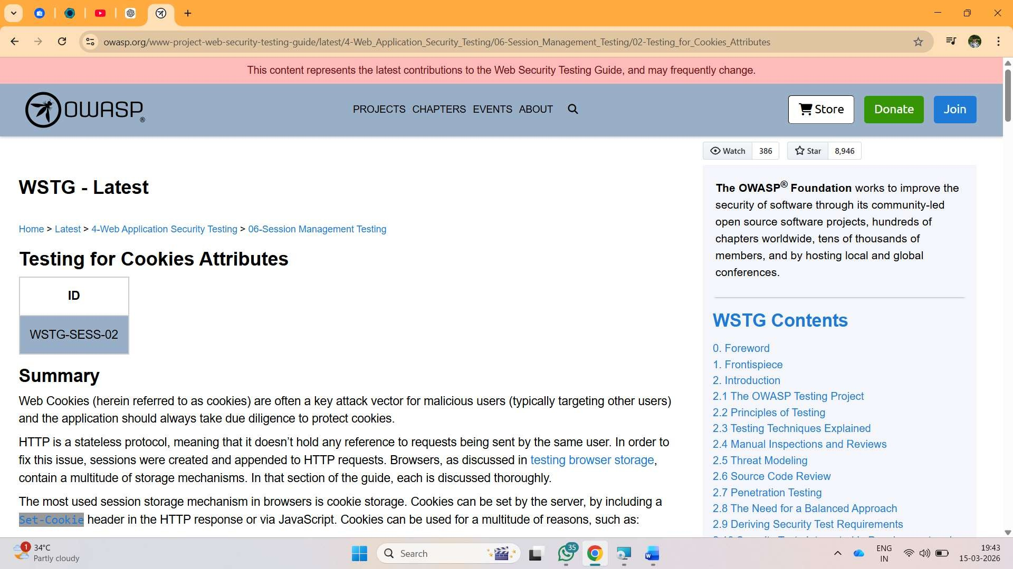

Vulnerability:Use of unmaintained third party Cwe/cve no:CWE 1104

DESCRIPTION:
Use of Unmaintained Third Party Components is a security vulnerability that occurs when an application depends on external libraries, frameworks, or software components that are no longer maintained or supported by their developers. These components may contain known security vulnerabilities that are not fixed because the developers have stopped providing updates or patches.
When applications use such outdated or unsupported components, attackers may exploit existing vulnerabilities in those components to gain unauthorized access to the system. Since the components are no longer maintained, there will be no security updates or fixes available to address newly discovered security issues.
This vulnerability can expose the application to various types of attacks such as data breaches, system compromise, or unauthorized access. Many modern applications rely on third-party libraries for faster development, but if these components are not regularly updated and monitored, they can become a serious security risk.
Therefore, organizations should regularly review and update third-party components, replace unsupported libraries with maintained alternatives, and ensure that all dependencies are updated to secure versions in order to reduce security risks.
BUSSINESS REPORT:
The vulnerability Use of Unmaintained Third Party Components can create serious security and operational risks for an organization. When an application depends on outdated or unsupported third-party libraries, those components may contain known vulnerabilities that attackers can easily exploit.
If attackers take advantage of these weaknesses, they may gain unauthorized access to the system, steal sensitive business data, or disrupt application services. This can lead to data breaches, system

compromise, and service downtime, which can directly affect business operations.
Such incidents may also damage the organization’s reputation and customer trust, especially if confidential customer or company data is exposed. In addition, businesses may face financial losses, legal issues, and regulatory penalties if security standards are not properly maintained.
Therefore, organizations must regularly review and update third-party components, remove unsupported libraries, and ensure that all dependencies are maintained and updated with the latest security patches to reduce security risks and protect business systems.

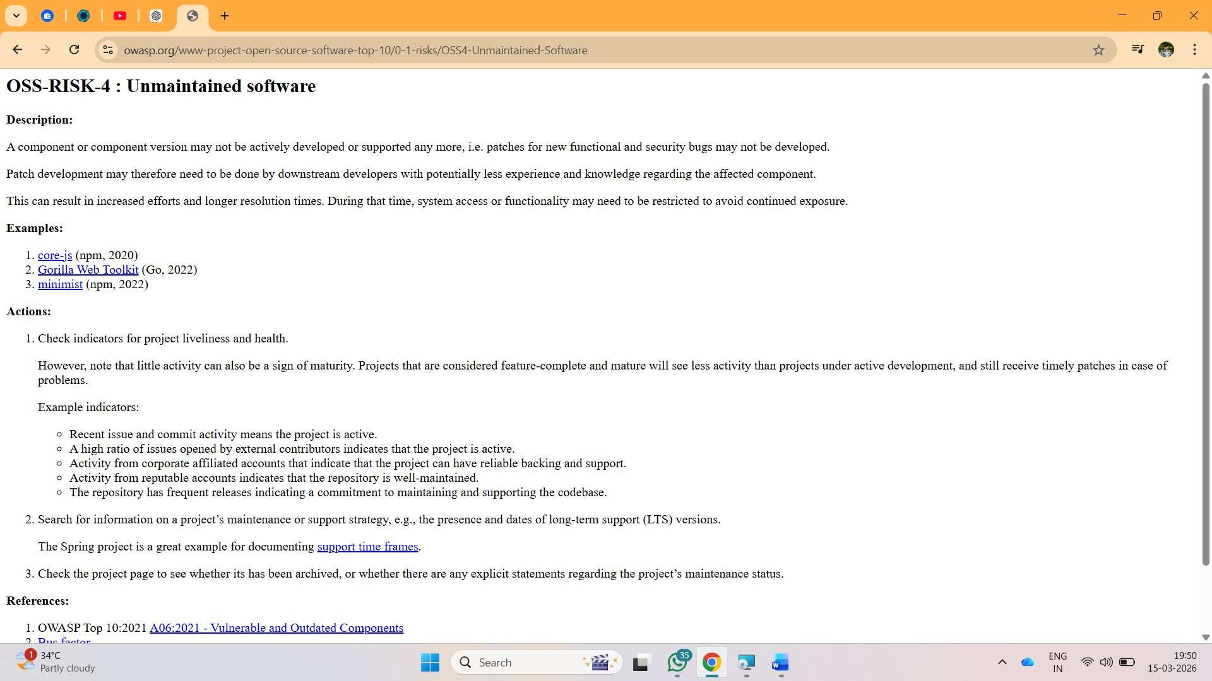

Stage 2
PROJECT TITTLE:NESSUS SCAN OVERVIEW:
Nessus is a widely used vulnerability scanning tool developed by Tenable. It is used to identify security vulnerabilities, configuration issues, and potential threats present in computer systems, networks, and applications. Nessus helps organizations detect weaknesses before attackers exploit them, making it an important tool in cybersecurity and vulnerability management.
A Nessus scan works by analyzing the target system and comparing it with a large database of known vulnerabilities such as CVE (Common Vulnerabilities and Exposures) and CWE (Common Weakness Enumeration). The tool performs automated security checks to identify problems like outdated software, insecure configurations, missing patches, and other security risks.
During the scanning process, Nessus generates a detailed report that includes information such as the vulnerability name, severity level, description, risk impact, and recommended solutions. These results help security teams understand the security posture of the system and take necessary actions to fix the identified vulnerabilities.
In this project, Nessus scanning is used to identify and analyze vulnerabilities present in the system. The scan results highlight security issues such as Absolute Path Traversal (CWE-36), Sensitive Cookie without Secure Attribute (CWE-614), and Use of Unmaintained Third Party Components (CWE-1104). By analyzing these vulnerabilities, appropriate security measures can be implemented to improve the overall security of the application.
Overall, Nessus scanning helps organizations proactively detect security weaknesses, reduce risks, and maintain a secure environment by ensuring that systems and applications follow proper security practices.

vulnerabilities Table:

sno | Vulnerability name | severity | Plugins
1 | Specific access | medium | 20006
2 | Absolute path  traversal | high | 11213
3 | Sensitive cookie in https session without secure  attrtibute | medium | 78479
4 | Use of unmaintained third party  components | medium | 91572

STAGE3:
TITTLE: Application-specific access policies using Zscaler Private Access (ZPA)

OVERVIEW:
Application-Specific Access Policies using Zscaler Private Access (ZPA) is a cloud-based security solution designed to provide secure access to internal applications without exposing the corporate network to the internet. In modern organizations, employees often work remotely and require access to company applications from different locations and devices. Traditional security methods such as Virtual Private Networks (VPNs) allow users to access the entire network once they are authenticated, which increases the risk of unauthorized access and cyber attacks.
Zscaler Private Access follows the Zero Trust security model, where no user or device is trusted by default. Instead, access is granted only after verifying the identity of the user and ensuring that the device meets the required security standards. With application-specific access policies, users are allowed to access only the particular applications they are authorized to use rather than the full network.
In this system, administrators can define policies based on factors such as user identity, department, device type, and location. When a user attempts to access an application, the request is validated by the Zscaler cloud platform. If the user meets all policy conditions, a secure and encrypted connection is established between the user and the application through the ZPA App Connector.
The main goal of this project is to demonstrate how organizations can implement secure and controlled access to internal applications using Zscaler Private Access. This approach improves network security, reduces the attack surface, and ensures that only authorized users can access sensitive resources within the organization.

IDENTITY:
The Identity section in the vulnerability assessment report provides basic information about the system or application that was scanned. It helps identify the target environment where the security scan was performed. This section typically includes details such as the target host name, IP address, operating system, scan date, and the scanning tool used.
In this project, the identity information helps define the system that was analyzed using the Nessus vulnerability scanner. It ensures that the scan results are associated with the correct target system and allows security analysts to track vulnerabilities identified in that particular environment.
The identity section also helps maintain proper documentation of the vulnerability assessment process. By clearly identifying the scanned system, organizations can easily monitor security issues, perform future scans, and compare results to check whether vulnerabilities have been fixed or still exist.
Overall, the Identity section plays an important role in maintaining accurate records of the security scanning process and helps in managing vulnerability reports effectively.

DEVICE POSTURE:
Device posture refers to the security condition or status of a user’s device before it is allowed to access an application or network resource. In modern cybersecurity systems, checking the device posture is an important step to ensure that only trusted and secure devices are permitted to access sensitive applications. This concept is widely used in Zero Trust security architecture.
In Zscaler Private Access (ZPA), device posture plays a key role in controlling secure access to internal applications. Before granting access, the system checks whether the device meets the required security standards defined by the organization. These checks help ensure that the device is safe and compliant with security policies.
Device posture verification can include several security checks such as whether the device has updated antivirus software, whether the operating system is up to date, whether disk encryption is enabled, and whether the device is managed by the organization. If the device fails to meet these security conditions, the system may deny access or restrict the user from accessing certain applications.
In ZPA, device posture information is collected through the Client Connector installed on the user’s device. When a user tries to access an internal application, the Client Connector sends the device posture information to the Zscaler cloud platform. The system then evaluates this information against the defined access policies to determine whether the device should be allowed to access the application.
This approach helps organizations enforce strict security controls by ensuring that both the user identity and device security are verified before granting access. Even if a user has valid login credentials, access will not be granted if the device does not meet the required security posture.
By implementing device posture checks, organizations can reduce the risk of security threats such as malware infections, unauthorized device access, and data breaches. It also helps maintain a secure working environment, especially for employees who access applications remotely from different locations.

Overall, device posture is an essential component in Application-Specific Access Policies using Zscaler Private Access (ZPA). It strengthens the Zero Trust security model by ensuring that only secure and compliant devices can access internal applications, thereby protecting sensitive organizational data and systems.

APPLICATION RISK:
Application risk refers to the potential security threats and vulnerabilities that may affect the performance, availability, and confidentiality of an application. In modern organizations, many business operations depend on web applications and internal enterprise applications. If these applications are not properly secured, they may become targets for cyber attacks and unauthorized access.
Common application risks include vulnerabilities such as unauthorized access, data leakage, weak authentication, insecure configurations, and outdated software components. Attackers may exploit these weaknesses to gain access to sensitive data, disrupt services, or compromise the entire system. These risks can lead to serious consequences such as financial losses, damage to the organization’s reputation, and loss of customer trust.
In the context of Application-Specific Access Policies using Zscaler Private Access (ZPA), application risk can be reduced by implementing strong access control mechanisms. ZPA follows the Zero Trust security model, which means that no user or device is trusted automatically.
Instead, every access request is verified before allowing the user to connect to the application.
ZPA reduces application risk by ensuring that users can access only the specific applications they are authorized to use rather than the entire network. This approach limits the exposure of applications to the internet and reduces the chances of attackers discovering or exploiting them.
Additionally, security policies can be applied based on user identity, device posture, and location, which further strengthens the protection of applications.
Regular vulnerability assessments, security monitoring, and proper configuration management are also important for minimizing application risks. By identifying vulnerabilities early and applying security patches, organizations can prevent attackers from exploiting weaknesses in the system.

CONTEXT AWARE ACCESS:
Context-Aware Access is a security approach that controls user access to applications based on different contextual factors such as user identity, device status, location, time, and network conditions. Instead of providing access based only on username and password, this method evaluates multiple conditions before allowing a user to access a system or application. This helps organizations improve security and reduce the risk of unauthorized access.
In modern cybersecurity environments, many users access applications remotely using different devices and networks. Because of this, traditional access control methods are not sufficient to protect sensitive data.
Context-Aware Access provides an additional layer of security by analyzing the context of each access request before granting permission.
In Application-Specific Access Policies using Zscaler Private Access (ZPA), Context-Aware Access plays an important role in implementing the Zero Trust security model. ZPA checks multiple factors before allowing a user to connect to an internal application. These factors may include the user’s identity, the security posture of the device, the geographic location of the user, and whether the device is managed by the organization.
For example, if an employee attempts to access an application from a trusted device within the company network, the system may allow access easily. However, if the same user tries to access the application from an unknown device or an untrusted location, the system may restrict access or require additional verification.
This approach helps organizations enforce strong security policies while ensuring that only authorized users can access sensitive applications. It also helps reduce the chances of cyber attacks such as account compromise, unauthorized access, and data breaches.
Overall, Context-Aware Access is an important feature in modern security solutions. By considering multiple contextual factors before granting access, organizations can improve their security posture and protect their applications and data from potential threats.

CONCLUSION:
STAGE 1:
In this project, a vulnerability assessment was performed to identify and analyze security weaknesses in the system. Using vulnerability scanning techniques, several security issues were detected and analyzed in detail. The three major vulnerabilities identified in this assessment include Absolute Path Traversal (CWE-36), Sensitive Cookie in HTTPS Session without Secure Attribute (CWE-614), and Use of Unmaintained Third Party Components (CWE-1104).
Each of these vulnerabilities can create serious security risks if not properly addressed. Absolute Path Traversal may allow attackers to access sensitive files on the server, while insecure cookie configurations can lead to session hijacking and unauthorized access. Similarly, using outdated or unsupported third-party components may expose the system to known security vulnerabilities and potential attacks.
By identifying these vulnerabilities through the scanning process, organizations can take appropriate corrective actions such as implementing proper input validation, configuring secure cookie attributes, and regularly updating third-party libraries. These security measures help in reducing risks and improving the overall security posture of the application.
In conclusion, vulnerability assessment plays an important role in maintaining system security. Regular security scanning and proper remediation of vulnerabilities help organizations protect sensitive data, prevent cyber attacks, and ensure that applications operate in a secure and reliable environment.

CONCLUSION:
STAGE2:
In this project, a vulnerability assessment was performed to identify and analyze security weaknesses in the system. Using vulnerability scanning techniques, several security issues were detected and analyzed in detail. The three major vulnerabilities identified in this assessment include Absolute Path Traversal (CWE-36), Sensitive Cookie in HTTPS Session without Secure Attribute (CWE-614), and Use of Unmaintained Third Party Components (CWE-1104).
Each of these vulnerabilities can create serious security risks if not properly addressed. Absolute Path Traversal may allow attackers to access sensitive files on the server, while insecure cookie configurations can lead to session hijacking and unauthorized access. Similarly, using outdated or unsupported third-party components may expose the system to known security vulnerabilities and potential attacks.
By identifying these vulnerabilities through the scanning process, organizations can take appropriate corrective actions such as implementing proper input validation, configuring secure cookie attributes, and regularly updating third-party libraries. These security measures help in reducing risks and improving the overall security posture of the application.
In conclusion, vulnerability assessment plays an important role in maintaining system security. Regular security scanning and proper remediation of vulnerabilities help organizations protect sensitive data, prevent cyber attacks, and ensure that applications operate in a secure and reliable environment

CONCLUSION STAGE3:
This project focused on analyzing application security by performing vulnerability assessment and identifying potential risks that may affect system integrity and data protection. With the help of vulnerability scanning techniques, several important security issues were detected and studied carefully. The main vulnerabilities identified in this project include Absolute Path Traversal (CWE-36), Sensitive Cookie in HTTPS Session without Secure Attribute (CWE-614), and Use of Unmaintained Third Party Components (CWE-1104).
The analysis of these vulnerabilities shows that even small security misconfigurations or outdated components can create major security threats for applications. Attackers may take advantage of these weaknesses to gain unauthorized access to sensitive files, hijack user sessions, or exploit outdated libraries within the system. Such incidents can lead to data exposure, system compromise, and operational disruption.
To reduce these risks, organizations must adopt proper security measures such as implementing strong access control policies, securing session management mechanisms, and ensuring that all software components are regularly updated and maintained. In addition, periodic vulnerability scanning and security monitoring are essential to identify new threats and maintain a strong security posture.
In conclusion, this project demonstrates the importance of proactive security practices in protecting applications and organizational resources. By identifying vulnerabilities early and applying appropriate mitigation strategies, organizations can significantly improve the security, reliability, and trustworthiness of their systems.

FUTURE SCOPE STAGE 1:
The field of cybersecurity is continuously evolving as new technologies and threats emerge. In the future, the implementation of application-specific access policies can be further improved by integrating more advanced security techniques and intelligent monitoring systems. As organizations increasingly adopt cloud computing and remote work environments, secure access to internal applications will become even more critical.
One possible future improvement is the integration of Artificial Intelligence (AI) and machine learning technologies for advanced threat detection and automated security analysis. These technologies can help identify unusual user behavior, detect potential attacks in real time, and automatically respond to security threats before they affect the system.
Another future enhancement is the implementation of stronger multi- factor authentication (MFA) and biometric authentication methods. This will provide an additional layer of protection by ensuring that only verified users can access sensitive applications and resources within the organization.
The use of advanced device posture verification can also be improved by incorporating real-time device health monitoring and security compliance checks. This will ensure that only secure and trusted devices are allowed to connect to organizational applications.
Additionally, organizations can expand the use of Zero Trust security architecture by integrating more security tools and platforms to create a unified security environment. Continuous monitoring, automated vulnerability scanning, and regular security updates will further strengthen application security.
In conclusion, the future scope of this project lies in enhancing application security through advanced technologies, stronger authentication mechanisms, and improved security monitoring systems. These improvements will help organizations protect their data, applications, and network infrastructure from evolving cyber threats.

FUTURE SCOPE:
STAGE 2:
As digital transformation continues to grow across industries, ensuring secure access to enterprise applications will become increasingly important. This project establishes a foundation for implementing secure application access through vulnerability assessment and controlled access policies. However, future developments can further enhance the effectiveness and reliability of such security frameworks.
One potential direction for future improvement is the integration of adaptive security mechanisms that dynamically adjust access policies based on real-time risk analysis. By evaluating user behavior, device trust level, and environmental factors, systems can make intelligent decisions about granting or restricting access to applications.
Another area of development is the expansion of automated security management, where security systems can continuously monitor vulnerabilities and automatically apply security updates or mitigation strategies. This approach will significantly reduce manual intervention and help organizations respond quickly to newly discovered threats.
Future systems can also focus on developing more scalable and flexible access control architectures that can support large-scale cloud infrastructures, hybrid networks, and globally distributed users. This will ensure that organizations maintain strong security standards while supporting modern digital work environments.
Furthermore, the use of advanced authentication technologies and continuous verification techniques can strengthen the Zero Trust model by ensuring that access privileges are maintained only while security conditions remain valid.
In conclusion, the future scope of this work lies in creating smarter, automated, and more adaptive security systems that can effectively safeguard applications and sensitive information in an increasingly complex digital ecosystem.

FUTURE SCOPE
STAGE 3:
The future development of this project can focus on improving application security through more advanced and intelligent security solutions. As cyber threats continue to evolve, organizations need stronger access control mechanisms to protect their applications and sensitive data.
In the future, security systems can incorporate automated vulnerability detection, real-time monitoring, and advanced authentication methods to enhance protection. Integrating intelligent technologies can help identify unusual user behavior and prevent potential attacks before they affect the system.
Additionally, expanding secure access policies to support cloud environments, remote users, and mobile devices will further strengthen the security framework. These improvements will help organizations maintain a secure, scalable, and reliable application environment.
Overall, future enhancements will focus on building smarter and more adaptive security systems that can effectively protect applications from emerging cyber threats.

TOPICS EXPLORED:owasp top 10,scanning,vulnerability,aweraness,identity
TOOLS EXPLORED:nesus,Owasp,hackthissite

